ELEC 1100 Laboratory 3: Summary Sheet

Name: __________________________ Student ID:

Notes:
(1) Show demo to your TA for an attendance record; bonus mark will be given to groups who can complete all TA Checks in the first 2 hours of your enrolled lab session.
LA2 (Fri, before 15:30), LA3 (Mon, before 12:30), LA1 (Tue, before 15:30)
(2) Individually submit your completed lab summary sheet to Canvas (LA1/LA2/LA3) “Assignments” before the deadline.
LA2 (Fri, deadline 16:20), LA3 (Mon, deadline 13:20), LA1 (Tue, deadline 16:20)

Experimental Results and Analysis

Q1: Sketch what you see on the DSO (both CH1 & CH2 waves, including the voltage & time scales and zero references displayed on the screen).
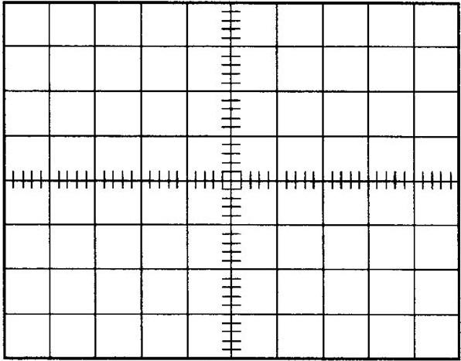
Notice: Do the sketching on the grid below by your hand, photos of DSO screen will NOT be accepted for grading.

Q2: What is the difference between the two waveforms? Briefly explain your answer (Explain the feature of a diode).
_____________________________________________________________________
_____________________________________________________________________
Q3: Complete the table of experiment results (2-resistor circuit).
V_{in} (V) | 1 | 2 | 3 | 4 | 5 | 6 | 7 | 8
V_{Z} (V)
V_{in} (V) | 9 | 10 | 11 | 12 | 13 | 14 | 15 | 16
V_{Z} (V)

Q4: Complete the table of experiment results (Zener diode circuit).
V_{in} (V) | 1 | 2 | 3 | 4 | 5 | 6 | 7 | 8
V_{Z} (V)
V_{in} (V) | 9 | 10 | 11 | 12 | 13 | 14 | 15 | 16
V_{Z} (V)

Q5: Use the data you record in Q3 and Q4 to make a line chart of V_{Z} against V_{in} and fill in the space provided below.

Q6: From your record in Q4, determine the breakdown voltage (give a rough number) of the Zener diode.
Breakdown voltage = _____________________
Q7: What is the multimeter reading (V_{out}) displayed when V_{in} = 8V? __________________
Q8: What is the multimeter reading (V_{out}) displayed when V_{in} = 12V? _________________
Q9: Use the results in Q7 and Q8, determine the line regulation of your LM7805 voltage regulator (Show your calculation).

